13.42: a) To the given precision, the small-angle approximation is valid. The highest
speed is at the bottom of the arc, which occurs after a quarter period, 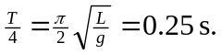
b) The same as calculated in (a), 0.25 s. The period is independent of amplitude.

